**Level 1: PC Tower Case**

**Outline**

Learn about the internals of a standard PC case by examining physical samples and selecting and labeling images found on-line. Gain deeper knowledge by researching and reporting on specific components.

**Questions**

1. Find one (or more) images that clearly show the internals of a PC Tower Case.   
   (i.e. Google images using keywords “PC Case Internals”)  
   “Understanding Your Computer Hardware” Bask Technology, <https://www.bask.com/blog/understanding-your-computers-hardware>

USB Expansion Ports, Monitor Ports, Audio Ports and Ethernet Ports

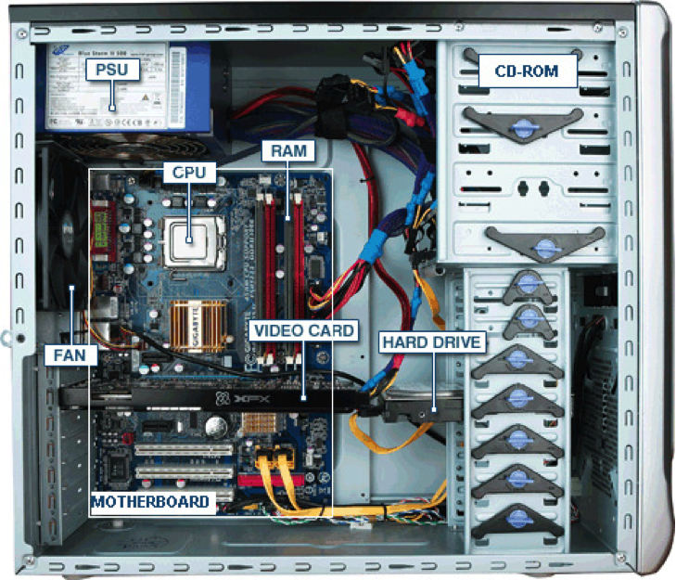

1. Clearly label the following components (using arrows) on your image of the PC case internals:
   1. Motherboard
   2. Power Supply
   3. Hard Disk Drive
   4. Optical Disk Drive (e.g.DVD)
   5. USB Expansion Ports
   6. Monitor Port
   7. Audio Ports
   8. Ethernet Port
   9. Cooling Fan
2. Research more in-depth about “Motherboards”. Make notes on the following:
   1. What different versions are currently available (speed and capacity)

Different versions available include AT, ATX, ITX, BTX

* 1. How the component has changed since the 1980’s  
     The size of motherboards from the 1980s were larger than they are today. The motherboards also did not allow interchangeability as they do today.

1. Research more in-depth about “Hard Disk Drives”. Make notes on the following:
   1. What different versions are currently available (speed and capacity)

Hard Drives come in a variety of capacity sizes and speeds. Such as 1 Terabyte in capacity and 7200rpm for speed

* 1. How the component has changed since the 1980’s  
     In the 1980s Hard Drives were 5.25 inches whereas today they come in 3.5 and 2.5 inch sizes.

**NOTE:**

* Download the on-line version of this module (from the class GitHub repository)
* Questions for Level 2 and Level 3 are in the on-line version of this module
* Provide your answers in a MS Word, PowerPoint, or equivalent format
* Upload your answers to your personal GitHub repository

**Level 2: PC Motherboard**

**Outline**

Learn about the structure of a standard PC motherboard by examining physical samples and selecting and labeling images found on-line. Gain deeper knowledge by researching and reporting on specific components.

**Questions**

1. Find one (or more) images that clearly show the layout of a PC Motherboard.   
   (i.e. Google images using keywords “PC Motherboard”)  
   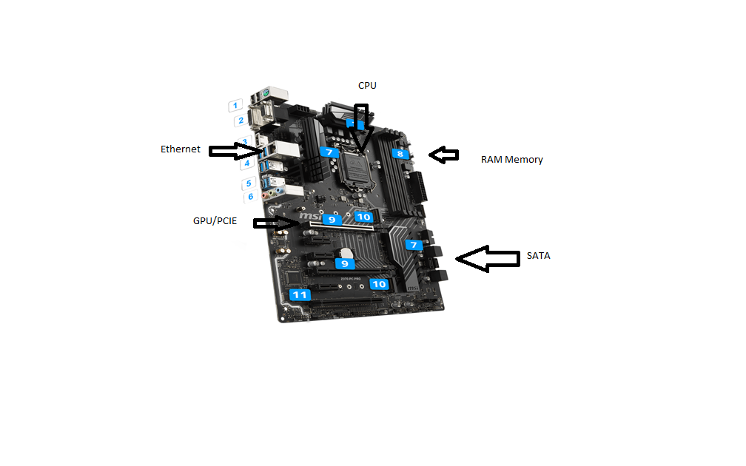
2. Clearly label the following components (using arrows) on your image of the PC motherboard:
   1. CPU (and fan)
   2. RAM Memory
   3. Disk Drive Interface (IDE or SATA)
   4. GPU Graphics Processor (either on-board or Graphics Card)
   5. Sound Processor (either on-board or Sound Card)
   6. Wi-Fi / Ethernet Network Interface (either on-board or Graphics Card)

1. Research more in-depth about “CPU Processor Chip”. Make notes on the following:
   1. What different versions are currently available (speed and capacity)

Intel sells different CPUs under their “Intel core i3, i5 and i7” products. AMD sell their processors under the “Ryzen 3, 5 and 7” brand.

* 1. How the component has changed since the 1980’s  
     In the 1980s processors used 16-bit or 32-bit architecture. Nowadays processors use the 64-bit architecture.

1. Research more in-depth about “RAM Memory”. Make notes on the following:
   1. What different versions are currently available (speed and capacity)

Memory currently is sold at DDR4 speeds. Most computers today are sold with 8GB of RAM.

* 1. How the component has changed since the 1980’s  
     RAM in the 1980s had far less capacity, the numbers were in the kilobytes. The speed of the RAM was also much slower than it is today.

**Level 3: Peripheral Devices**

**Outline**

Learn about how peripheral devices are connected to the back side of a typical PC tower case. Examine physical samples, select and labeling images found on-line and gain deeper knowledge by researching and reporting on specific components.

**Questions**

1. Find one (or more) images that clearly show the layout of the back of a typical PC tower case.   
   (i.e. Google images using keywords “Back Of PC Tower”)
2. Clearly label the following components (using arrows) on your image of the back of a typical PC tower case:
   1. Power cord and power switch
   2. Monitor Interface (VGA or DVI or HDMI)
   3. Mouse Interface (USB or PS/2)
   4. Keyboard Interface (USB or PS/2)
   5. USB Ports
   6. Audio Inputs / Outputs
   7. Ethernet Interface

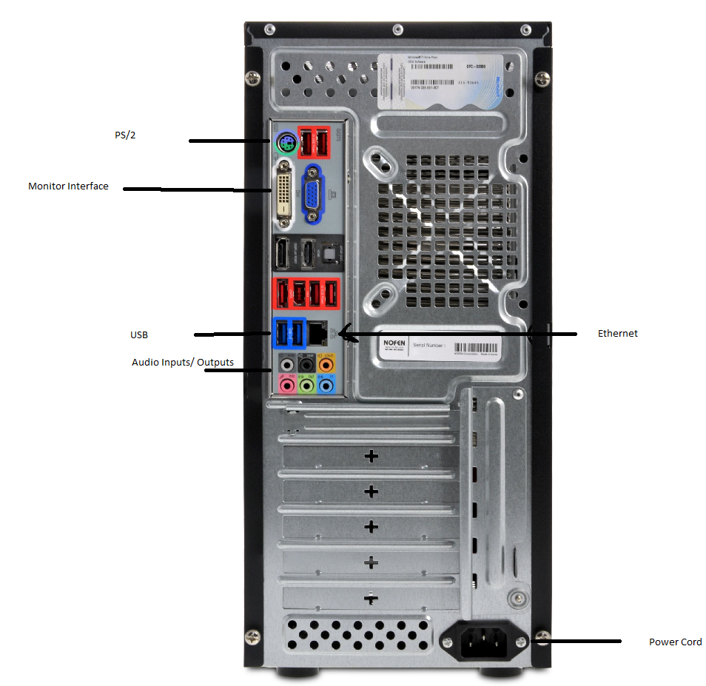

1. Research more in-depth about “Monitor Technology”. Make notes on the following:
   1. What different versions are currently available (e.g. VGA / DVI, Flat Panel Technology))

Different monitor technology used today are HDMI and DisplayPort.

* 1. How the component has changed since the 1980’s (e.g. Display Resolution, Technology)  
     Resolutions on monitors in the 1980 were smaller. The technology used in the 1980s was VGA cables while today HDMI is used to connect monitor to the computers.

1. Research more in-depth about “External Portable Storage”. Make notes on the following:
   1. Floppy Disks

Rectangular disks that store data. Were later replaced CD and DVD.

* 1. CD-ROM / DVD / Recordable CD/DVD

Circular Discs that store data and you can write data onto.

* 1. USB Memory Drives

USB memory Drives are portable drives that plug into a USB port instead of SATA like traditional storage drives.

* 1. Compact Flash Memory

Compact Flash Memory is used in storage devices such as SD and MicroSD cards.

* 1. Cloud Based Storage  
     Cloud based storage is when storage is uploaded to a server instead of being saved on a hard drive.

**Level 4: PC Component Presentation**

**Outline**

Explore the development and features of a specific PC hardware component through deeper research and investigation. Work in partners to create a short presentation. Deliver the presentation to the class.

Each group will research a unique PC hardware component . Your specific topic will be assigned from the list provided below.

**Presentation Structure**

1. Explain what the PC component does and how it fits together with other components to make up a fully functioning PC.
2. Explain how the PC component works. Provide a diagram (image) showing the main parts of the component.
3. Research the current state of the art of the component in terms speed, capacity (size), and other related factors.
4. Research on-line suppliers that sell the PC Component. List the specifications for the available products and the cost (price).
5. Research how the PC component has changed and evolved since the early days of PCs in the 1980’s. Cover each of the following topics separately:
   1. Component Speed
   2. Component Size / Capacity
   3. Two other specifications specific to the PC component (ask Mr. Nestor)

**PC Component Topics**

|  |  |  |
| --- | --- | --- |
| **Topic** | **Partner 1** | **Partner 2** |
| CPU Microprocessor Chip |  |  |
| Motherboard Layout |  |  |
| Computer Graphics |  |  |
| Sound & Audio |  |  |
| Hard Disk Drives |  |  |
| Removable Disk Storage |  |  |
| Network / Internet Connectivity |  |  |
| Mouse / Pointing Devices |  |  |
| Monitor & Display Technology |  |  |
| Printers & Output Technology |  |  |